DSC 423: Data Analysis and Regression Assignment 07

Saransh Thakur  
Id: 2020070

Problem 1

1. We separated the data into two categories: training data and testing data, with training data accounting for 80% of the total, and testing data accounting for 20%. Then, we train our model on training data and predict the outcome on testing data.

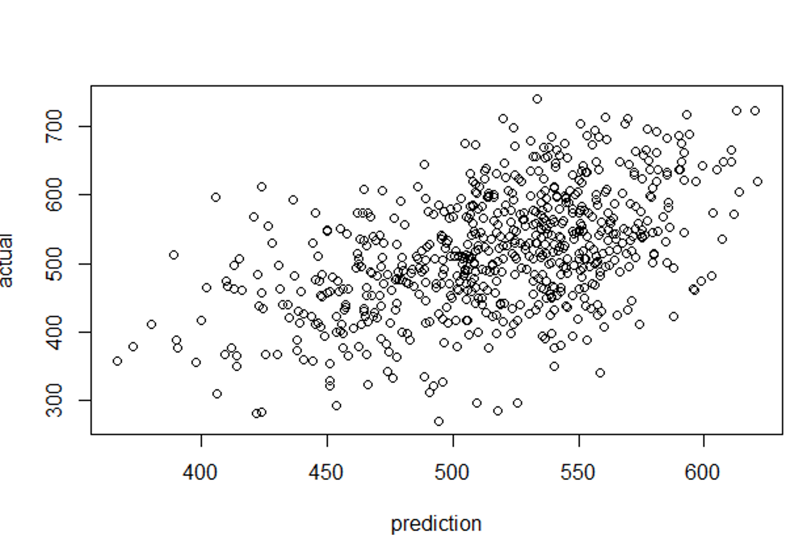

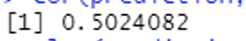

According to the above plot, it has a positive direction as well as a linear shape, and it has a moderate positive correlation with outliers, and the actual value and predicted value are correlated at 54%.

1. **Univariate**: -

Uni means one and variate means variables. So, in univariate analysis, there is only one dependable variable. The goal of the univariate analysis is to extract data, characterize and summarize it, and assess the pattern it contains. It examines each variable individually in a dataset.

Univariate can be described through

1. Frequency distribution table.
2. Bar chart
3. Histogram
4. Pie chart
5. Frequency polygon

Below are a few examples of the univariate using histogram.

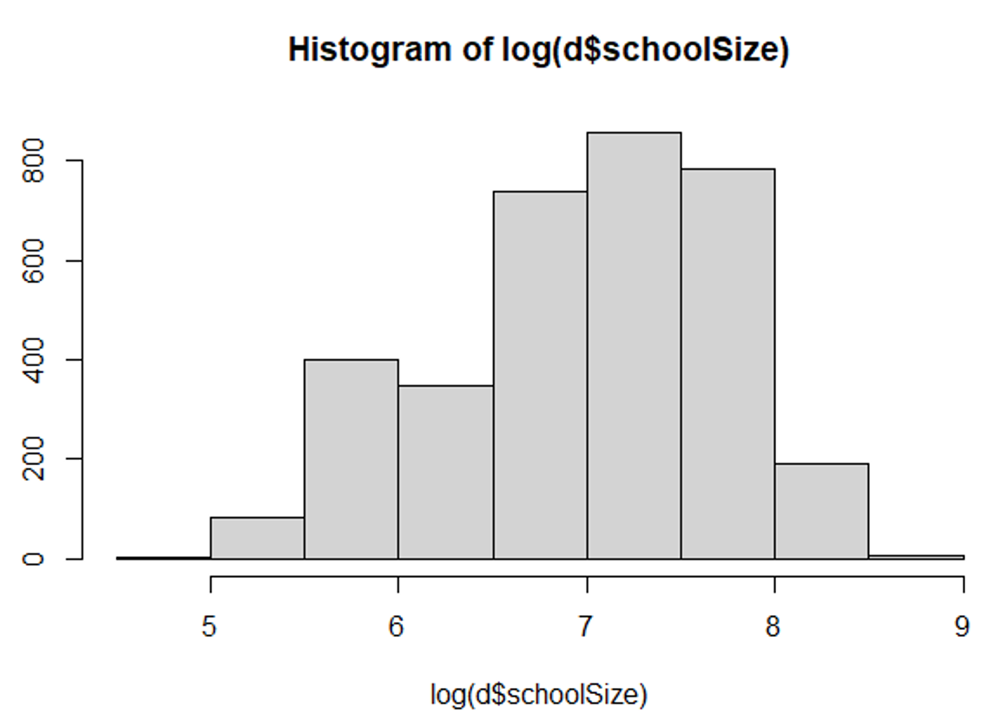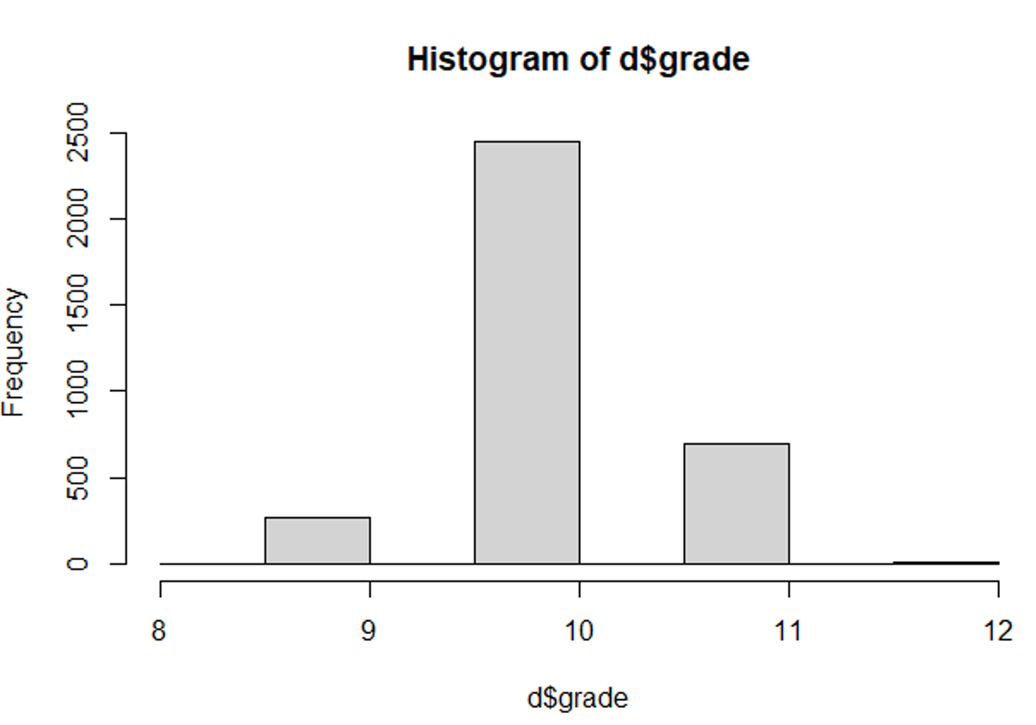

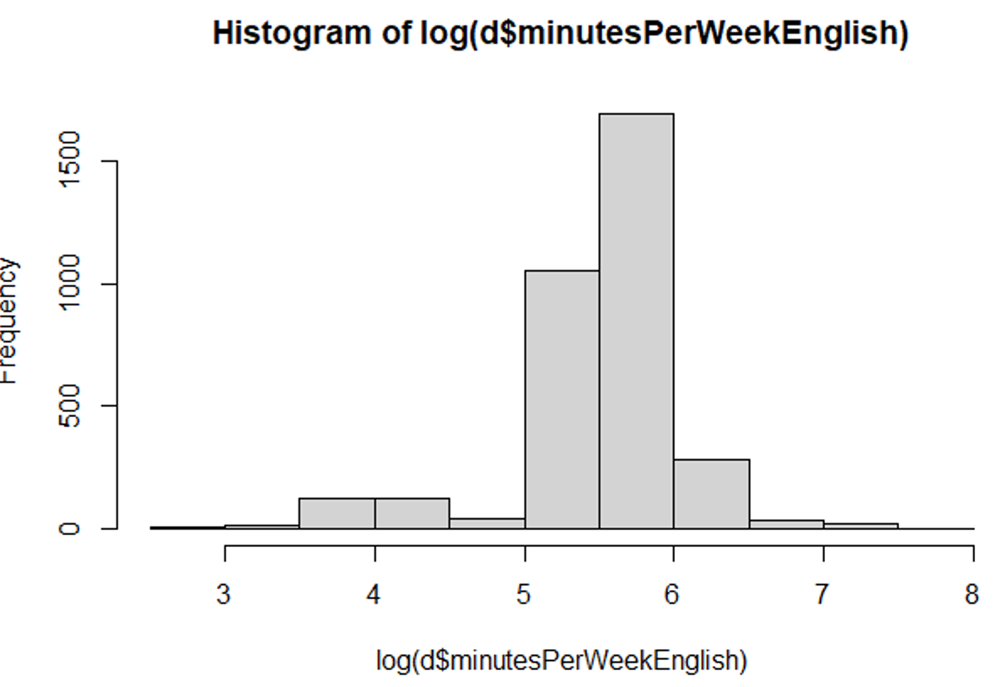

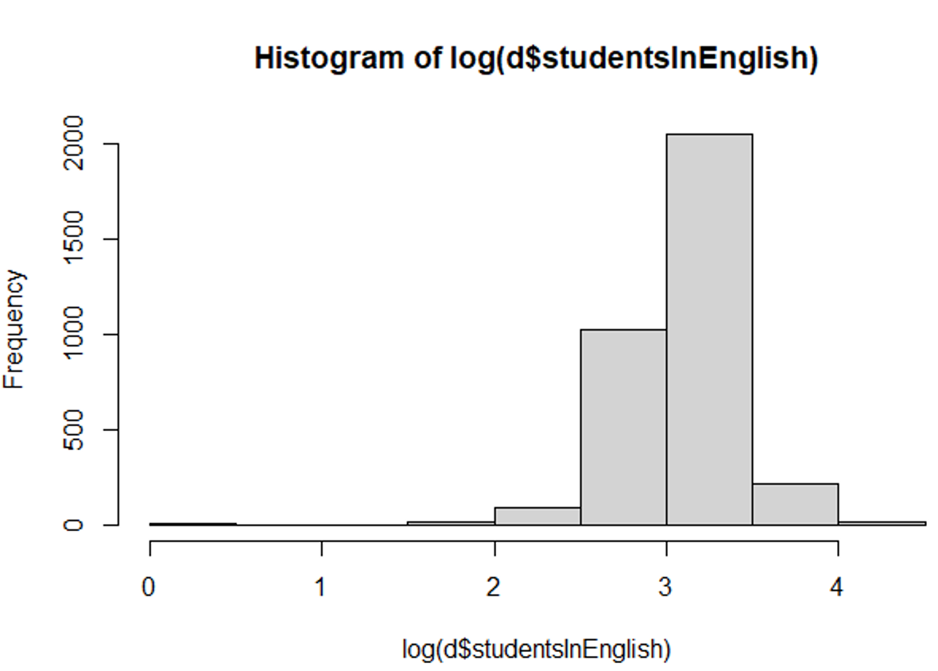

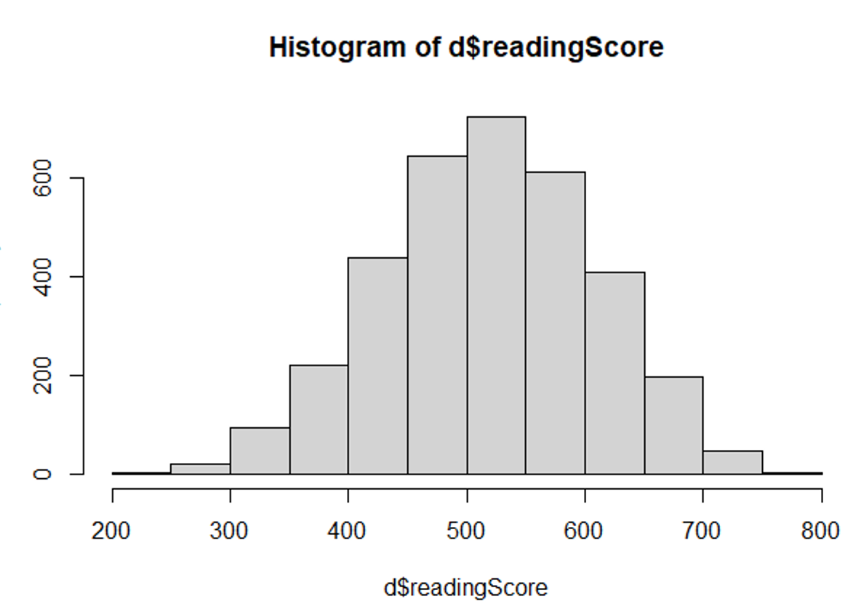

**Bivariate variables: -**

Bi means two and variate means variable, so here there are two variables. The analysis is related to the cause and the relationship between the two variables.

The bivariate analysis consists of

1. Scatter plot
2. Correlation

Below are examples of scatter plots and correlations.

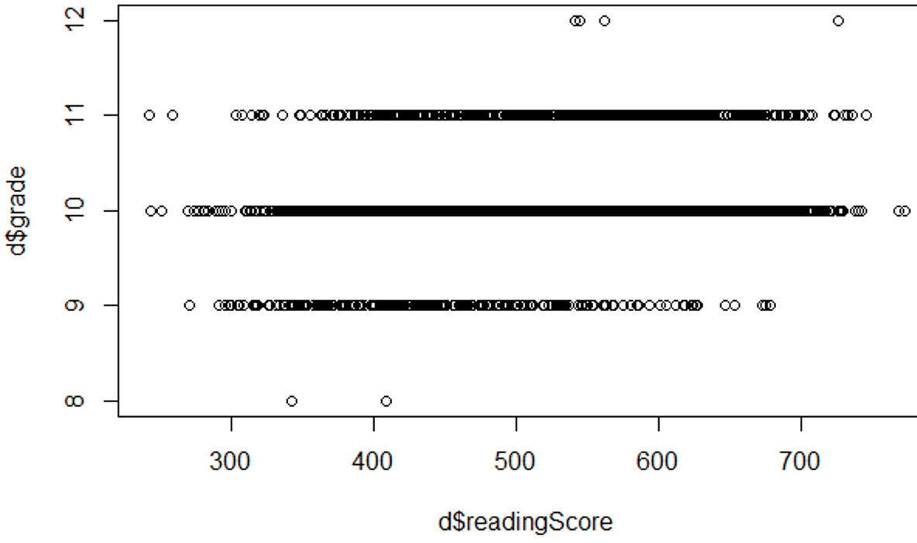

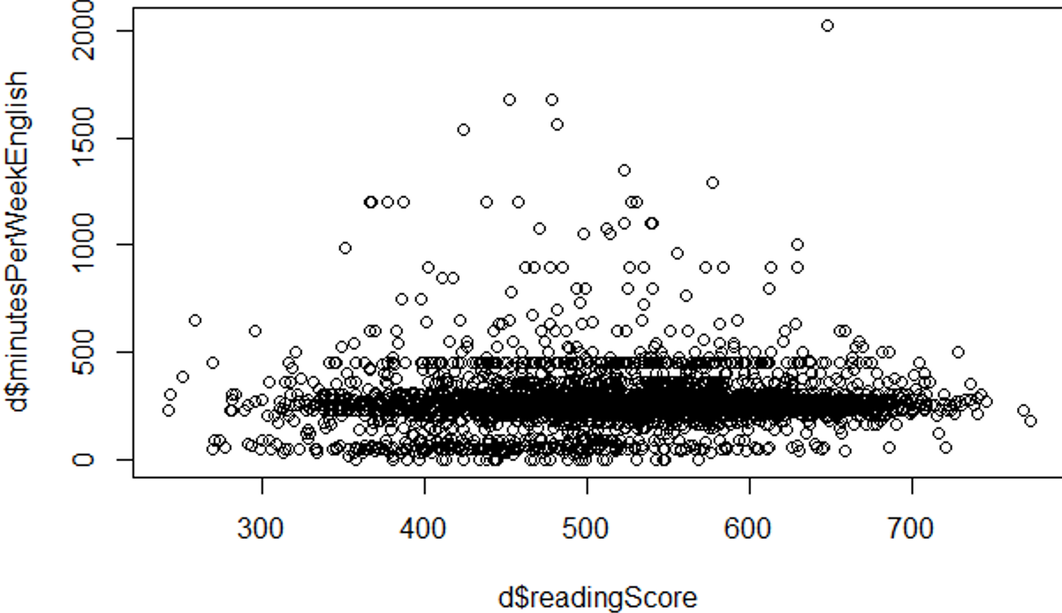

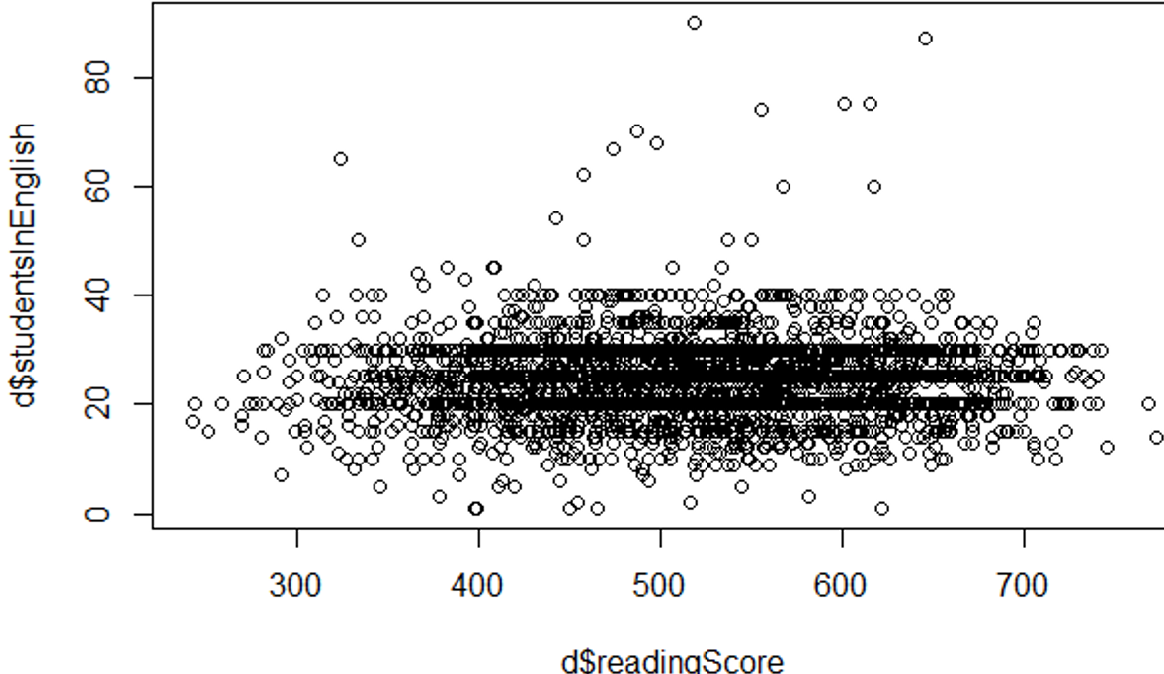

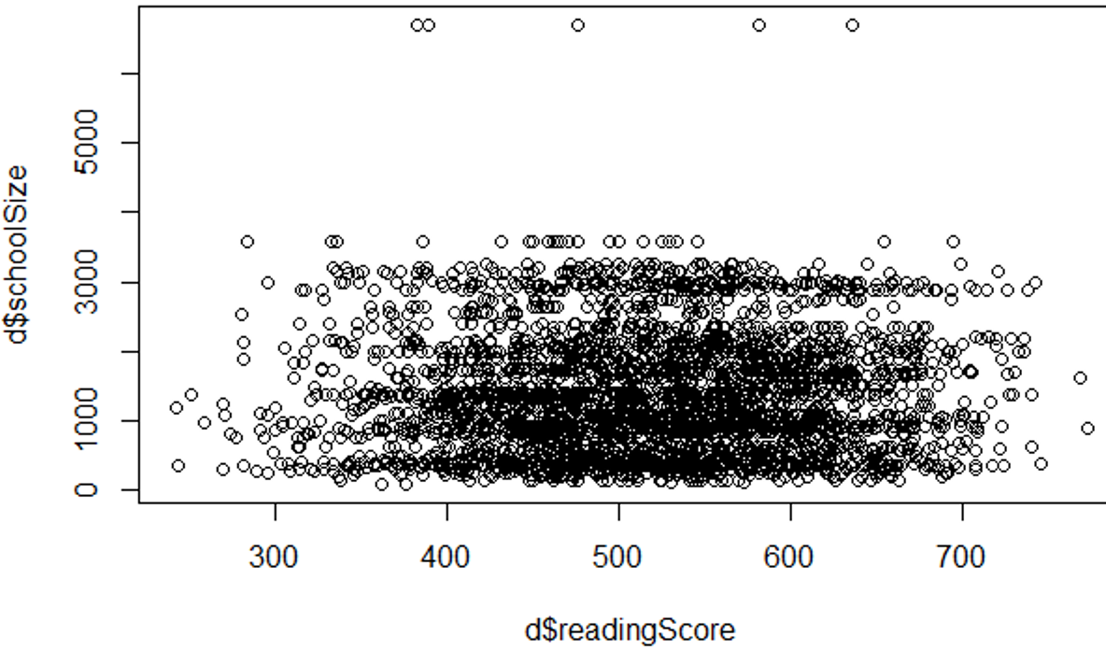

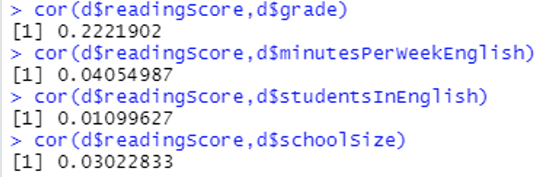

1. We employ two ways to test for multicollinearity. We can either use cor or the VIF model to check.
2. **Using cor**

If the variables in the model are highly correlated between pairs of independent variables, the variables are multicollinear.

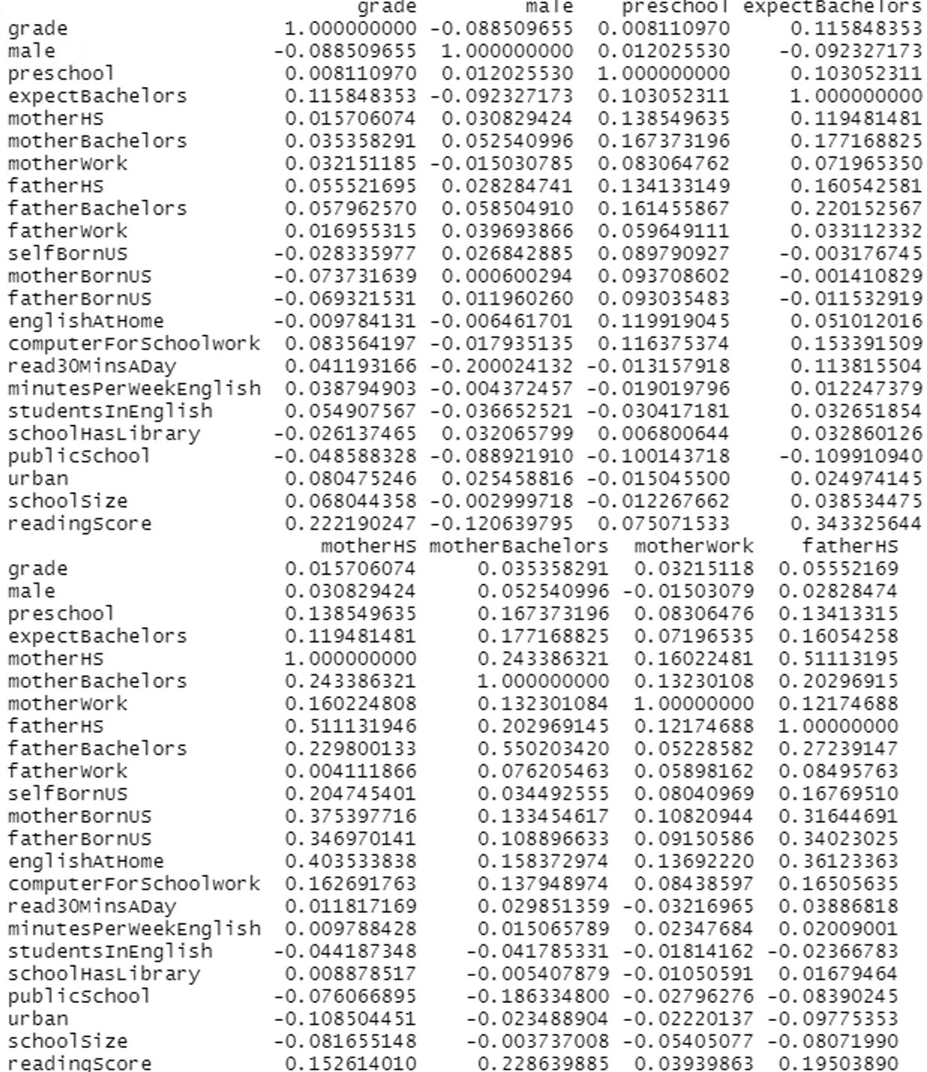

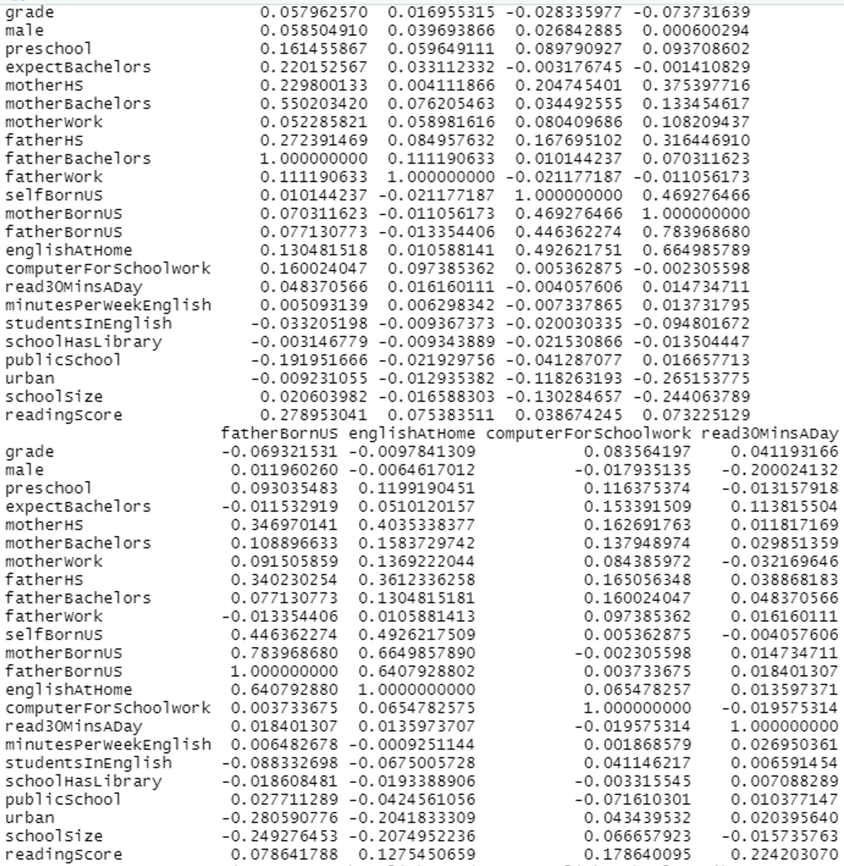

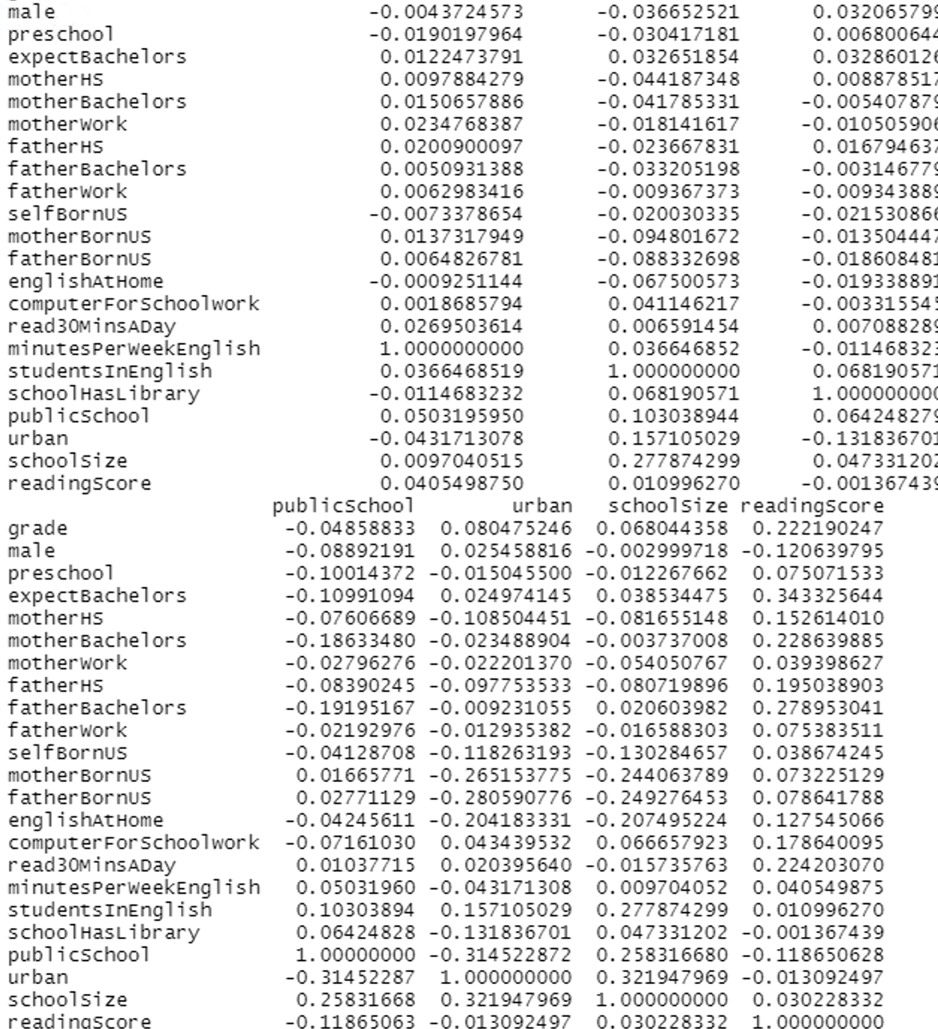

None of the variables in the preceding example are highly correlated with one another, indicating that there is no multicollinearity between them.

1. Using **VIF model**

If the VIF is more than 10, we can assert that the variables are highly associated, and it explains 90% of the variation in the predictor.

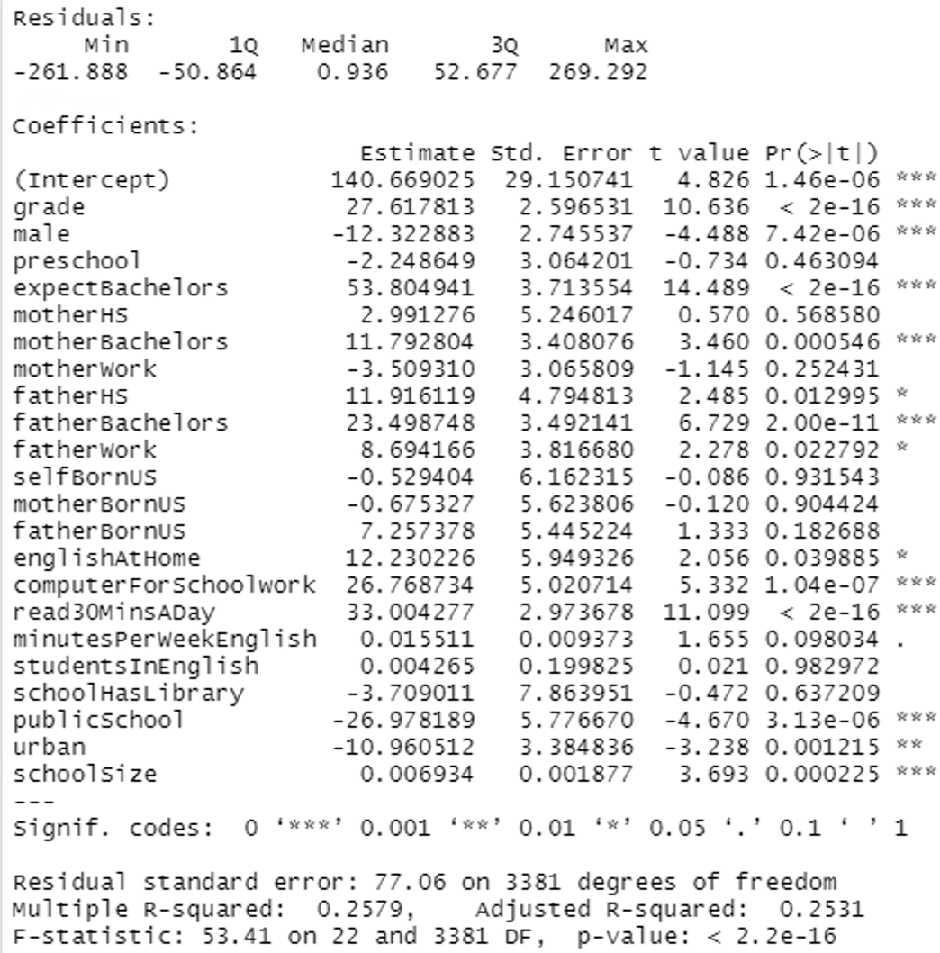

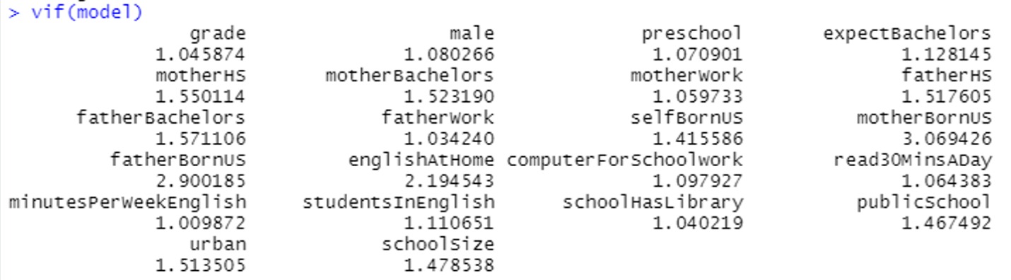

In this scenario, all the variables have a VIF of less than 10, indicating that they are not associated with one another.

**VIF will identify multicollinearity if Correlation misses it.**

1. Creating dummy variable

d$male<- ifelse(d$male == "male", 1, 0)

d$preschool<-ifelse(d$preschool == "preschool",1,0)

d$expectBachelors<-ifelse(d$expectBachelors == "exceptBachelors",1,0)

d$motherHS<-ifelse(d$motherHS == "motherHS",1,0)

d$motherBachelors<-ifelse(d$motherBachelors == "motherBachelors",1,0)

d$motherWork<-ifelse(d$motherWork == "motherwork",1,0)

d$fatherHS <-ifelse(d$fatherHS == "fatherHS",1,0)

d$fatherBachelors<-ifelse(d$fatherBachelors == "fatherBachelors",1,0)

d$fatherWork<-ifelse(d$fatherWork == "fatherwork",1,0)

d$selfBornUS<-ifelse(d$selfBornUS == "selfBornus",1,0)

d$motherBornUS<-ifelse(d$motherBornUS == "motherBornus",1,0)

d$fatherBornUS<-ifelse(d$fatherBornUS == "fatherBornus",1,0)

d$englishAtHome<-ifelse(d$englishAtHome == "englishAtHome",1,0)

d$computerForSchoolwork<-ifelse(d$computerForSchoolwork =="computerFOrSchoolwork",1,0)

d$read30MinsADay<-ifelse(d$read30MinsADay == "read30MinsADay",1,0)

d$schoolHasLibrary<-ifelse(d$schoolHasLibrary == "schoolHasLibrary",1,0)

d$publicSchool<-ifelse(d$publicSchool == "publicschool",1,0)

d$urban<-ifelse(d$urban == "urban",1,0)

1. Feature Selection using Backward selection
2. Begins with a model that contains all variables under consideration (called the *Full Model*).
3. Then starts removing the least significant variables one after the other.
4. Until a pre-specified stopping, the rule is reached or until no variable is left in the model

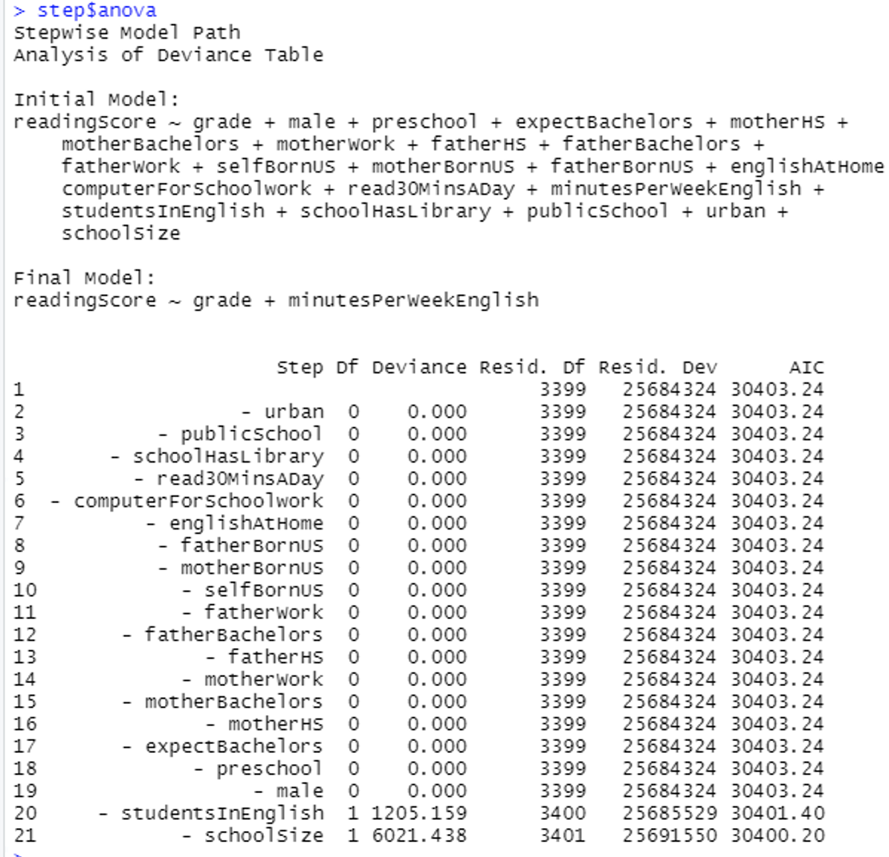

Feature selection using **forward selection**

1. Begins with a model that contains no variables (called the *Null Model*).
2. Then starts adding the most significant variables one after the other.
3. Until a pre-specified stopping rule is reached or until all the variables under consideration are included in the model.

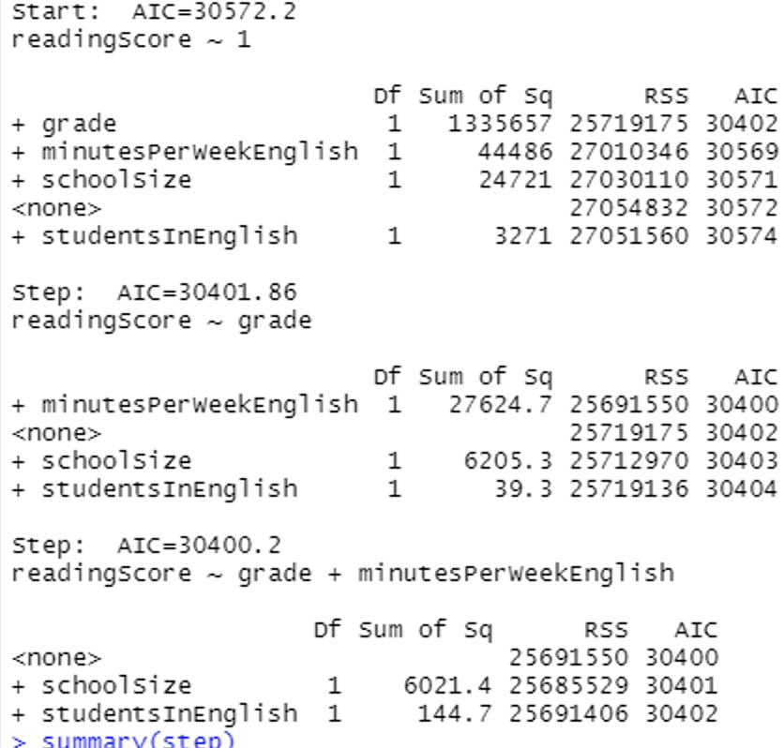

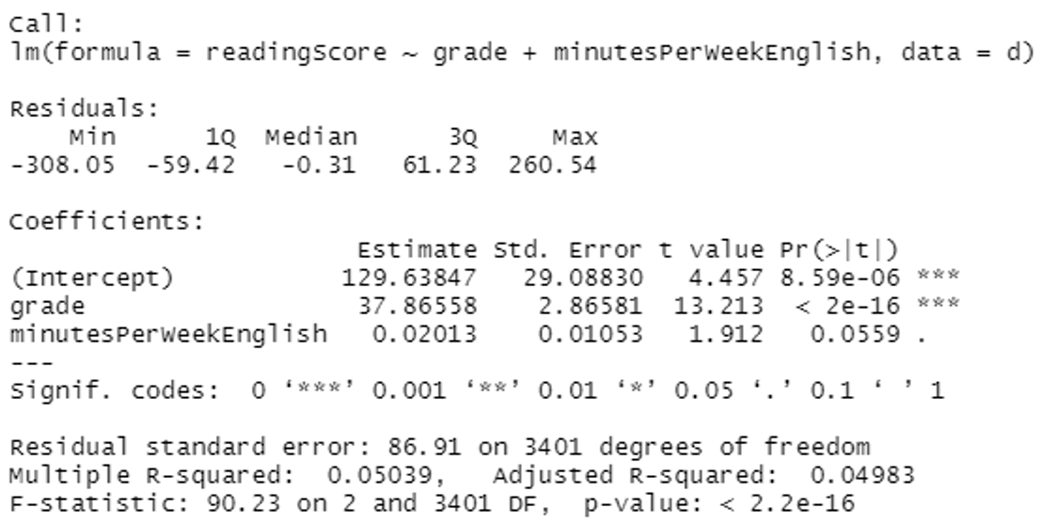

1. The second-order model is

d$minutesPerWeekEnglishSQ <- (d$minutesPerWeekEnglish)^2

d$gradeSQ <- (d$grade)^2

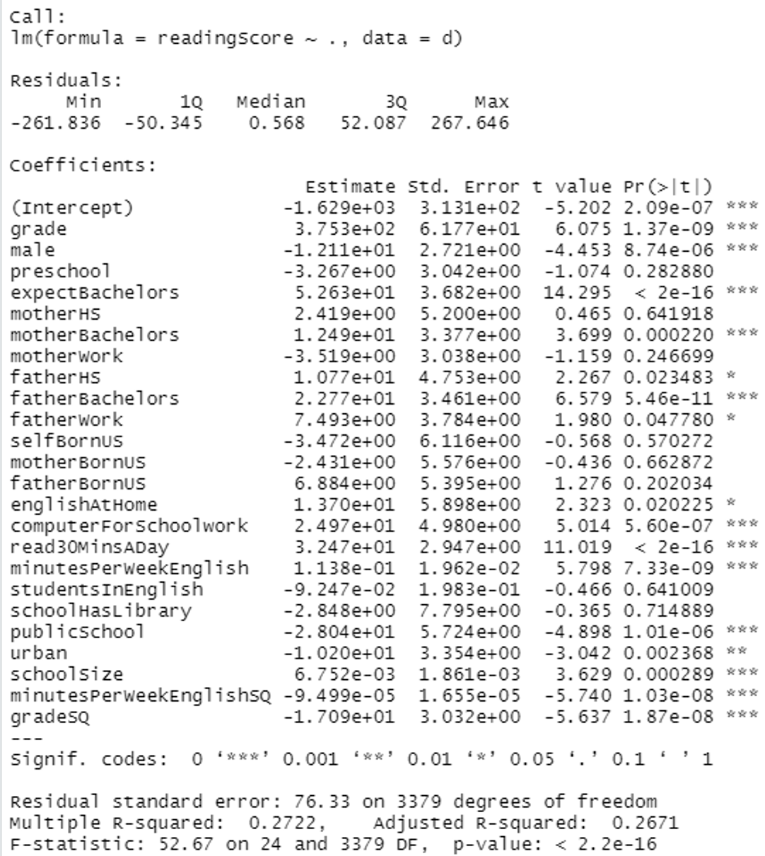

F-test has a very low P-value, this means that we reject the null hypothesis i.e. (all the Betas are equal to zero) and accept the alternative hypothesis that at least one is not equal to zero.

It tells that something in the model is working.

For, grade, male, expect bachelor, other bachelors, father bachelor, computer for schoolwork, urban, school size, read30MinsADay, minutesPerWeekEnglish, grades, and minuteperweekenglishSQ, we reject the null hypothesis and accept the alternative hypothesis, all of which are less than 0.05. Our model explains 26.71 percent of the variability in y, according to the corrected R-squared of 0.2671.

Using **backward selection** on the model.

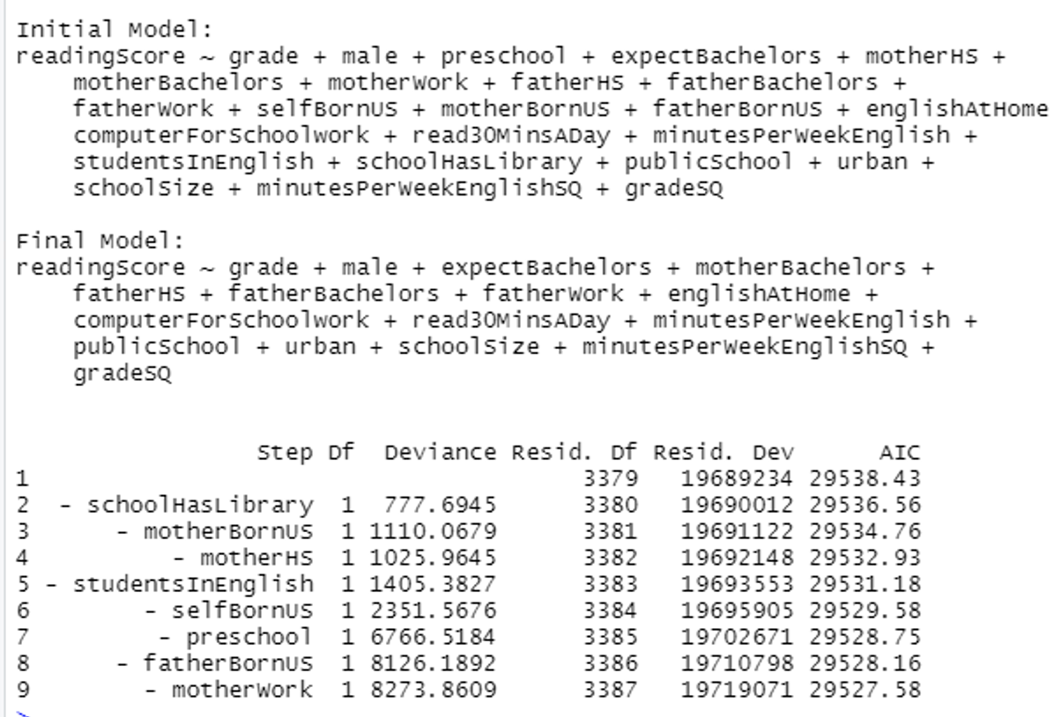

So, the final model is

**readingScore ~ grade + male + expectBachelors + motherBachelors +**

**fatherHS + fatherBachelors + fatherWork + englishAtHome +**

**computerForSchoolwork + read30MinsADay + minutesPerWeekEnglish +**

**publicSchool + urban + schoolSize + minutesPerWeekEnglishSQ +**

**gradesSQ**

1. The **interaction model** is

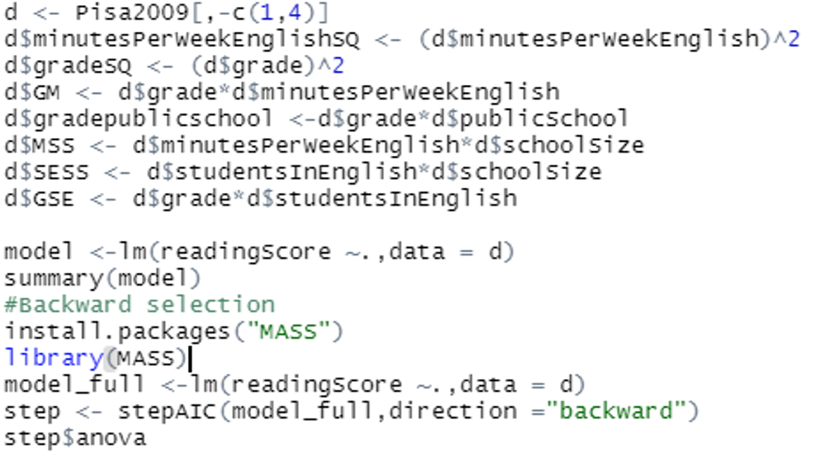

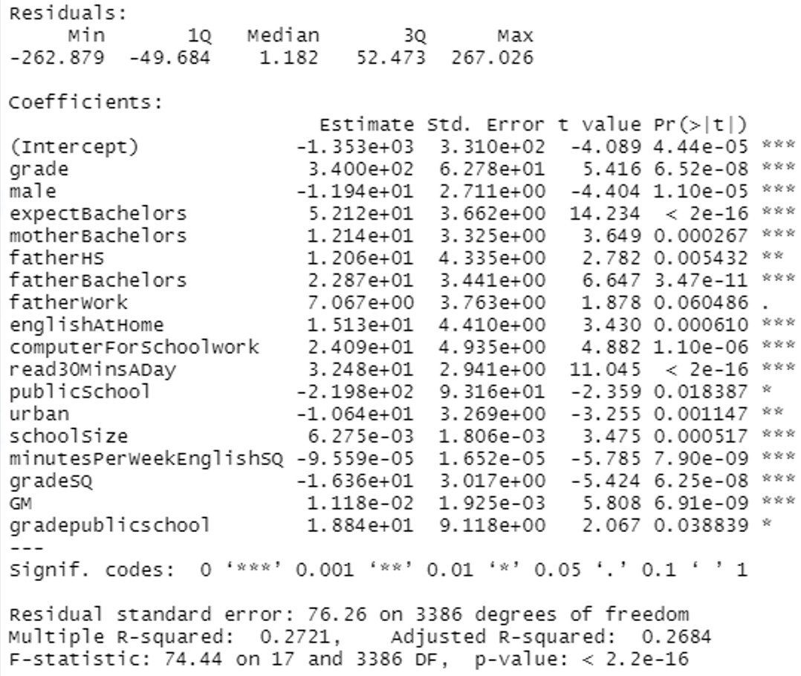

The F-test has a very low P-value, which suggests that we reject the null hypothesis (all Betas are equal to zero) and accept the alternative hypothesis that at least one is not equal to zero.

It indicates that something in the model is working.

For, grade, male, expect bachelor, other bachelors, father bachelor, computer for homework, urban, school size, read30MinsADay, minutesPerWeekEnglish, grades, minuteperweekenglishSQ, GM and grade public school, we reject the null hypothesis and accept the alternative hypothesis, all of which are less than 0.05. According to the adjusted R-squared of 0.2684, our model explains 26.84 percent of the variation in Y.

1. **Transform variables are**: -

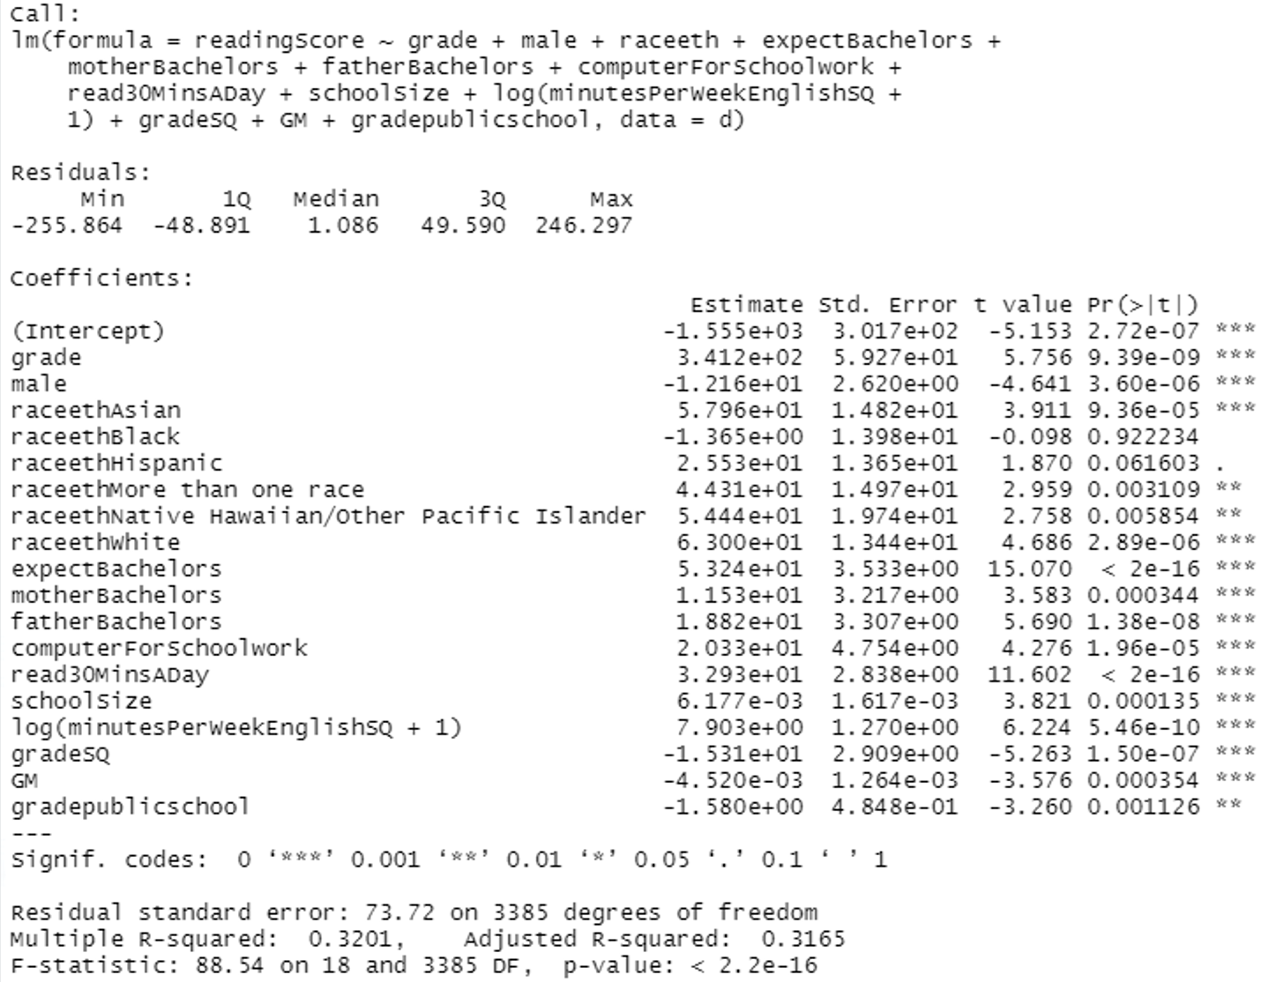

The F-test has a very low P-value, which suggests that we reject the null hypothesis (all Betas are equal to zero) and accept the alternative hypothesis that at least one is not equal to zero.

It indicates that something in the model is working.

For, grade, male, raceethAsian, raceethBlack, raceethNative Hawaiian/Other Pacific Islander, racket white, expect bachelor, other bachelors, father bachelor, computer for schoolwork, read30MinsADay, log (minutesPerWeekEnglishSQ + 1), grades, GM, and grade public school, we reject the null hypothesis and accept the alternative hypothesis; they all fall below the significance level of 0.05. The adjusted R-squared is 0.3165, indicating that our model explains 31.65% of the variability in y.

1. **Final model is**

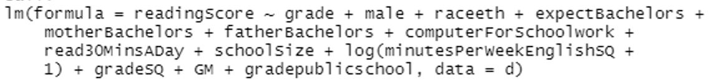

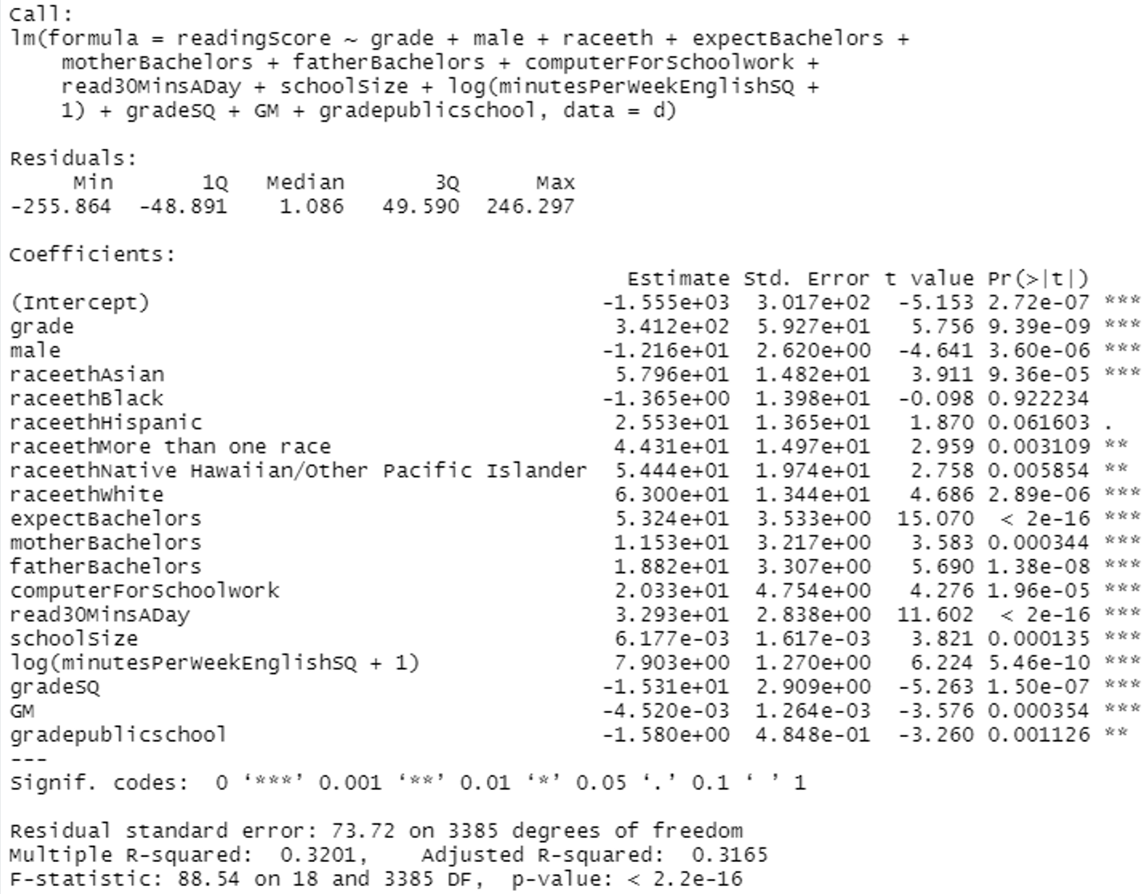

F-test has a very low P-value, this means that we reject the null hypothesis i.e. (all the Betas are equal to zero) and accept the alternative hypothesis that at least one is not equal to zero.

It tells that something in the model is working.

For, grade, male, raceethAsian,raceethBlack,raceethNative Hawaiian/Other Pacific Islander, racket white, expect bachelor, other bachelors, father bachelor, computer for schoolwork,read30MinsADay, log(minutesPerWeekEnglishSQ + 1), grades, GM and grade public school we reject the null hypothesis and accept the alternative hypothesis, they all lie under the significance value of 0.05. The adjusted R-squared is 0.3165 which means 31.65% variability in y is explained by our model.

1. The Programme for International Student Assessment (PISA) is a three-year exam given to 15-year-old students from all around the world to measure their performance in mathematics, reading, and science. This test provides a quantitative instrument for comparing the performance of students from across the world. In this homework project, we will forecast the reading scores of students from the United States of America on the 2009 PISA exam. Reading score is determined by grades, minutes per week of English, and 30 minutes of reading each day, according to the data we studied. These factors have a p-value of less than 0.05, therefore they pass the t-test and f-test, and they account for 31.65% of the variance in reading score. These variables influence the reading score. All these characteristics are directly proportional to the reading score.